ST BENEDICT’S COLLEGE


SUBJECT | English Paper 1 | DATE | November, 2017
GRADE | 11 | MARKS | 90
EXAMINER | Mrs Nichas, Mr Brouard | MODERATOR | Mrs Oosthuysen, Mrs Leeburn, Mrs Nichas
NAME |  | DURATION | 2 ½ hours
CLASS

COGNITIVE LEVELS
LOW ORDER | 54 % | MIDDLE ORDER | % | HIGH ORDER | 46 %

STUDENT’S RESULT
COMMENT
TEACHER’S SIGNATURE

question 1: cOMPREHENSION 25 marks
Read TEXT 1, Life is an Eroding Beach and answer the questions below.

1.1 Explain the effectiveness of starting the text with a rhetorical question. (2)
The questions points to the ridiculousness of such a question. Not many people would have thought of this. It involves the reader into the conversation.
1.2 Explain how the diction and the tone of the column contribute to the writer’s intention. (3)
Informal language used, “not so, friends”; cliché phrases, “like sands in the hour glass” inform the tone – tongue-in-cheek, philosophical, pensive. His intention is to raise awareness.
1.3 Why does the writer mention that she doubts whether “Knowledge is power” (paragraph 3)? (3)
Too much knowledge leads to confusion, therefore it is disempowering and causes anxiety. She feels anxious about the sand problem in the world and the Wikileaks saga.
1.4 Explain the metaphorical reference to Popeye in paragraph 4. (2)
Popeye – a cartoon character of a sailor who becomes strong when he eats spinach. In this context, she is using it to refer to a person having so much information that their brain swells like Popeye.
1.5 “Almost everything related to food manufacture and preparation.” (paragraph 6) Identify and correct the grammatical error in this sentence. (1)
No finite verb, no subject. “I wish I didn’t know about problems/errors related to food manufacture and preparation.” (Anything suitable.)
1.6 What is the function of the hyphen in “better-off-not-knowing category” (paragraph 7)? (1)
Joining words to form a compound adjective.
1.7 Explain the shift in meaning in the idiomatic expression “Real kick in the teeth/face” as it has been used in paragraphs 8 and 11. (2)
In paragraph 8, the idiom refers to something that you didn’t expect or that upsets you. In paragraph 11, it refers to the literal meaning of being kicked in the face.
1.8 Explain the humour expressed by the writer in relation to her teacher’s aphorism (a concise statement that contains a general truth) in paragraph 9. (2)
Rhyming has nothing to do with wisdom. The writer is mocking the saying or pointing to a childlike belief that pithy statements have to be true.
1.9 What is suggested about how the writer views herself when she says that “16 year later, I think of it almost daily” in paragraph 9? (1)
She is still affected by the insult she received. Her self-esteem is still affected.
1.10 To what extent is Shankar Vedantam’s (the host of the “Hidden Brain” podcast) opinion surrounding knowledge reliable? Explain your answer. (3)
It is purely his opinion and therefore cannot be considered to be reliable. An opinion cannot be trusted as absolute truth.
Boys can also argue that his opinion might be reliable as he quotes economists and learned people and therefore supports his views with those of knowledgeable people who have researched this topic.
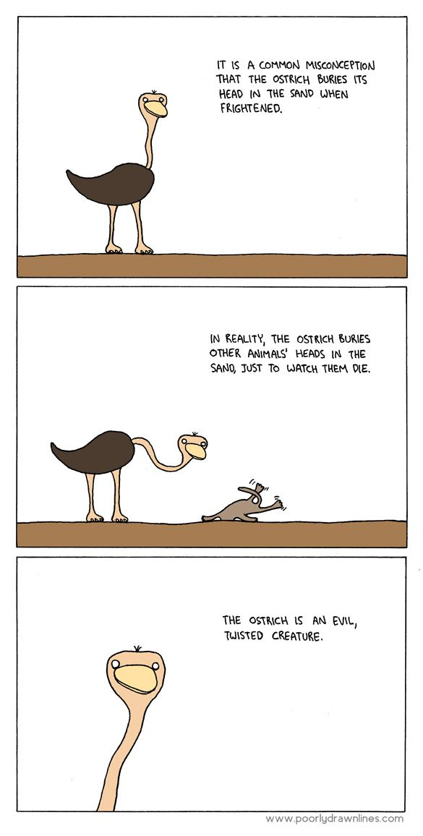
1.11

Considering the message of the cartoon above and Text 1, evaluate, by using examples from your own experience, whether you agree with Rebecca Davis’ interpretation regarding the “Ostrich effect”. (5)
Text 1 refers to not wanting to know everything. “Ignorance is bliss” is the preferred state of being. The message of the cartoon becomes harsher saying that it is not about ignoring information or not wanting to know about it, but actually harming others who have information in order to perpetuate the ‘ignorance is bliss’ idea. Boys could also argue that some people are so insistent that they remain ignorant, that they will prevent others from informing them and therefore could be considered ‘evil’. Plus own experience.
QUESTION 2: SUMMARY 10 MARKS
Read TEXT 2, Rise of the Drones and answer the following question.

As a technological enthusiast, you have been asked to address a group of scientists at a conference for Drone development. By summarising TEXT 2, present your views on the positive and negative effects of drone technology in the world.

Take note of the following:
- Your summary must be in the form of ONE paragraph, using no more than 90 words.
- Your language use must be accurate and in an appropriate register.
- Do not include the title provided in your word count.
- Provide an accurate word count at the end of the summary.
- Use your own words. ‘Cutting and pasting’ of information is not acceptable.

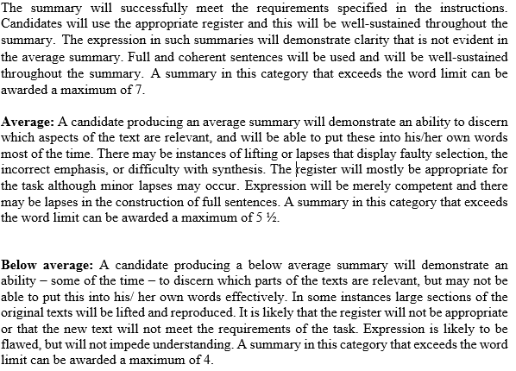
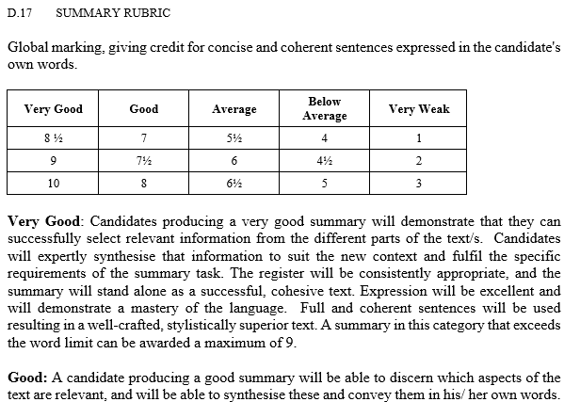

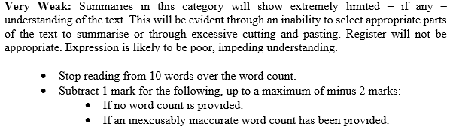
question 3: poetry 30 marks
Read The Pauper and Decomposition and answer the questions that follow.

Seen Poem: The Pauper by Richard Ntiru
Pauper, pauper, craning your eyes
in all directions, in no direction!
What brutal force, malignant element
dared to forge your piteous fate?
Was it worth the effort, the time? 5

You limply lean on a leafless tree,
nursing the jiggers that shrivel your bottom,
like a baby newly born to an old woman.
What crime, what treason did you commit,
that you are thus condemned? 10

And when you trudge on your horny pads,
gullied like the soles of modern shoes,
pads that even jiggers cannot conquer.
Does He admire your sense of endurance
or turn his head away from your impudent presence? 15

You sit alone on hairless goatskins,
your ribs and bones reflecting the light
that beautiful cars reflect on you,
squashing lice between your nails
and cleaning your nails with dry saliva. 20

And when He looks at the grimy coating
caking off your emaciated skin,
at the rust that uproots all your teeth,
like a pick on a stony piece of land.
Does He pat his paunch at the wonderful sight? 25

Pauper, pauper crouching in beautiful verandas
of beautiful cities and beautiful people.
Tourists and I will take your snapshots.
And your MP with a shining head and triple chin
will mourn your fate in a supplementary question at Question Time. 30

3.1 Using your knowledge of the connotation of the word “malignant”; what does Ntiru imply about the presence of the pauper in lines 3-4? (2)
The poet is asking what cancerous (malignant) force created the Pauper. Poverty has not been created by the poor but by forces beyond their control and by greedy governments.
3.2 What commentary is the poet making in lines 16-18 regarding the issue of charity and the inequality found within Ugandan society? (2)
The rich do not regard the pauper, they merely drive by in their beautiful cars. It’s ironic that there is such wealth in such poverty in Ugandan society. Clearly the society does not give the poor anything and they are forced onto the streets and live on ‘hairless goatskins’.
3.3 Describe the tone of the lines mentioned in 3.2? Justify your answer by quoting from the poem. (2)
Ironic, scathing. “Your ribs and bones reflecting the light that beautiful cars reflect on you.”
3.4 Explain how the enjambment in lines 17/18 and again in lines 19/20 helps to create meaning. (2)
The enjambment makes the movement of the pauper fluid and slow. There is a contrast between the slow and graphic actions of the pauper squashing lice in his nails and the movement of the expensive cars going past him.
3.5 Explain how the use of repetition and sentence structure affects the mood of the final stanza. (3)
The repetition of ‘pauper, pauper’ and ‘beautiful’ emphasises the plight of the pauper and how grotesque his situation is. ‘Beautiful’ highlights the disparity between the rich and the poor. The final stanza speaks of the selfishness of the government officials who do not care about the poor and their issues become only part of a ‘supplementary’ question – of secondary importance in their agendas. They are all overweight and overindulged. The mood is gloomy, cynical.

Unseen Poem: Decomposition by Zulfikar Ghose
I have a picture I took in Bombay 1
of a beggar asleep on the pavement:
grey-haired, wearing shorts and a dirty shirt,
his shadow thrown aside like a blanket.
His arms and legs could be cracks in the stone, 5
routes for the ants’ journeys, the flies’ descents,
Brain-washed by the sun into exhaustion,
he lies veined into stone, a fossil man.
Behind him there is a crowd passingly
bemused by a pavement trickster and quite 10
indifferent to this very common sight
of an old man asleep on the pavement.
I thought it then a good composition
and glibly called it The Man in the Street ,
remarking how typical it was of 15
India that the man in the street lived there.
His head in the posture of one weeping
into a pillow chides me now for my
presumption at attempting to compose
art of his hunger and solitude. 20

3.6 The word composition means “the nature of something” or “a creative work especially a poem or piece of music”. The poem’s title however, is Decomposition. By referring to the words Composition and Decomposition, explain the central message of the poem. (3)
The poet attempts to take a photo/make a picture (composition) out of someone’s suffering and feels guilty for it. He acknowledges a beggar’s ‘decomposed’ state, being ‘broken down’ - “hunger and solitude” and his attempt to “compose art” out of it.
3.7.1 Identify the figure of speech in line 8. (1)
Metaphor

3.7.2 Why is this comparison (line 8) so powerful in describing the situation of the sleeping beggar? (2)
The beggar is so thin that he has become part of the stone pavement, carved into it like a fossil.
3.8 The poet states that the people are ‘indifferent’ to the sight of the beggar. Quote another word from the poem that highlights the indifference of people? (1)
glibly
3.9 To whom does the idiomatic expression, the man on the street refer? Why is it ironic that the poet would give his photograph that title? (3)
The average, common man. The beggar is not an average man, he is below average, one who suffers and represents the lowest in our society.
3.10 In both The Pauper and Decomposition, similar images are used to show the physical state of the beggar/ pauper. Compare two images (other than the image referred to in 3.7) from each poem used to draw the reader into the plight of the beggar. (4)
Pauper imagery – “trudging on horny pads”, “grimy emaciated skin”, “craning to see” – these images portray the horrific state of the beggar. He has been on the street for a long time and time and the elements have aged him.
Decomposition imagery – “grey-haired, wearing shorts and a dirty shirt”, “his arms and legs could be cracks in the stone”, “his head in the posture of one weeping” also indicate the pitiful state of the beggar, how thin he is, how old and how hopeless his situation is.

3.11 Examine the following quote and accompanying picture and then answer the question that follows.
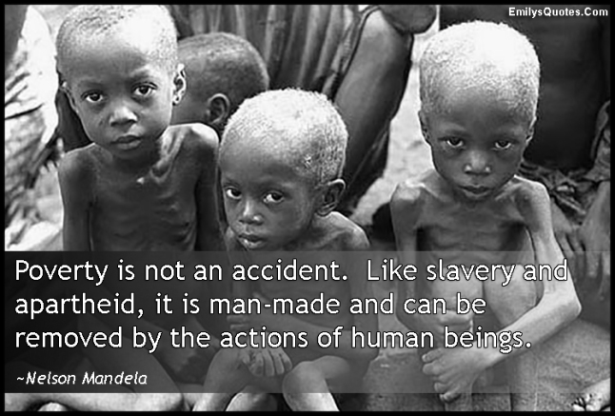

To what extent do you agree that poverty is created and human suffering is often seen as inspiration for an art form rather that inspiration to help and eradicate poverty. Quote from the VISUAL, the SEEN and UNSEEN poem to support your argument. (5)
Poverty is created by systems, governments, people and their greed. We take pictures and feel sorry for those in this situation but don’t do much to prevent it. Social media makes us aware of pictures like the one above that raise awareness for the condition of the poor but little is done to combat it. These pictures become an art form and are displayed across various forms of media. “Tourists and I will take your snapshots” from The Pauper and “attempting to compose art out of his hunger and his solitude” from Decomposition highlight this fact. Boys however, also need to argue that there are people who do much to help alleviate poverty, who donate thousands to those in need and offer much relief for their situations. There are organisations like The Red Cross, UNESCO and others who do great work in relief effort and therefore cannot be accused of simply making art out of suffering.
question 4 – visual literacy 20 marks
Study TEXTS 3, 4 and 5 and answer the questions that follow. TEXTS 3 and 4 have been produced by Amnesty International – a non-governmental organisation which seeks to ensure human rights globally.

4.1 By referring to visual and verbal details, explain the satirical message of TEXT 3. (4)
A person is attempting a smile but his/her teeth are covered in barbed wire to look like braces. The advertiser uses words such as ‘freely’ and ‘freedom’ to indicate that in many countries the opposite is happening. Many people do not have the luxury of ‘freedom of speech’ and are constrained, even jailed for speaking out against the prevailing order.
4.2 Considering what Amnesty International does, assess the relevance of their logo. (2)
The logo is a candle that is lit to symbolise their company being a light perhaps for those whose right have been abused. They offer hope to the oppressed. It is therefore appropriate.
4.3 Explain the irony inherent in TEXT 4. Refer to visual details to support your answer. (3)
Books are supposed to educate you, open your mind and teach you something different and interesting. They are not supposed to lead to your death or harm you. The open book would indicate a new knowledge being gained, the red bookmark in the shape of a hang man’s noose would suggest that many authors risk their lives to have their work published.

4.4 Explain why censorship would be detrimental in a democratic society. (2)
Censorship prevents freedom of speech and therefore goes against a democratic society which seeks to encourage the voice of the people.
4.5 Refer to TEXT 5. This book has just been published in South Africa and stock is limited. From the verbal details, what do you believe the book’s content will reveal? (2)
The book will reveal who the people are who have kept our president in power. It suggests that they are criminals who have been covering up crimes for Zuma and therefore have kept him out of prison. It suggests that Zuma is a criminal too and this book will expose him. “keeping Zuma in power and out of prison”.
4.6 How would the visual of TEXT 5 add to the tone of the title of the book? (2)
The laughing face of Zuma adds to the satirical/critical tone of the title.
4.7 Do you believe that Jacques Paux will need help from Amnesty International in the next few months following the release of this book? Explain your answer with reference to TEXTS 3 and 4 and your own knowledge. (3)
Text 4 suggests that authors will be hanged for speaking out against an order. Text 3 suggests that those who speak out will be jailed or prevented from doing so. Considering that Paux is already facing charges of treason and revealing sensitive information, he will need the help of Amnesty international.
4.8 Explain the pun on the word ‘dynamite’ in TEXT 5. (2)
Dynamite – an explosive and dynamite – someone being very powerful and dynamic.
question 5 – textual editing 5 marks
Read TEXT 6 and answer the questions that follow.

5.1 Identify the register of this text. Quote to support your answer. (2)
The register is informal – “like a seasoned pro”, “received goodies”
5.2 Identify the error of concord in sentence 3. (1)
The fashion industry ‘wasn’t’ not ‘weren’t’
5.3 Write a dictionary entry for the neologism, ‘tastemaker’ as it is used in this text. Include a part of speech and a definition of the word. (2)
Tastemaker (n): a person who makes new trends in fashion, one who is tasteful in their fashion choices.

Questions/levels | 1 and 2 | 3 | 4 | 5 | 6 | 7
1.1 |  | 2
1.2 |  | 3
1.3 | 3
1.4 | 2
1.5 | 1
1.6 | 1
1.7 |  | 2
1.8 |  |  | 2
1.9 |  | 1
1.10 |  |  |  | 3
1.11 |  |  |  |  | 5
3.1 |  | 2
3.2 | 2
3.3 |  |  | 2
3.4 |  | 2
3.5 |  |  | 3
3.6 |  |  | 3
3.7 | 1 | 2
3.8 | 1
3.9 |  |  | 3
3.10 |  |  | 4
3.11 |  |  |  | 5
4.1 |  |  | 4
4.2 |  | 2
4.3 |  | 3
4.4 |  | 2
4.5 | 2
4.6 | 2
4.7 |  |  |  | 3
4.8 | 2
5.1 | 2
5.2 | 1
5.3 | 2
Total lower order: 43 (54%)
Total higher order: 37 (46%)

TEXT 1
LIFE IS AN ERODING BEACH
The leading cause of despair? TMI, about everything
- Did you know the world is running out of sand? On a planet ravaged by global warming, you’d think dwindling sand reserves would be the one thing we didn’t need to worry about. My vision of our future sees everyone trudging through mountains of sand. You’d think there would be more than enough to go around.
- Not so, friends. We do indeed have loads of sand, but it is the most in-demand element other than water and air. Only some sand is suited for construction purposes – and it’s a finite resource. To get the sand we need to build modern cities, we are now pillaging forests and riverbeds and beaches. There are sand mafias in India, and international sand cartels. Like sands through the hourglass, so are the days of our lives.
- To be honest, I would rather not know that we’re running out of sand. It’s just one more thing to add to an ever-expanding list of anxieties about which I can do nothing. “Knowledge is power,” people say. I beg to differ. The relationship between knowledge and power is much fuzzier than everyone pretends. Knowing about the world’s sand crisis does not make me feel empowered in the slightest. In fact, it makes me feel the opposite: sad, anxious, and confused about whether I should start stockpiling it.
- Merely learning something new does not magically transform you into an informational Popeye. Sometimes, by contrast, it makes you want to pull a duvet over your head and not get out of bed for a week. Not all knowledge is power. Sometimes the power lies in not knowing.
- It’s not just sand that I’d rather not know about. I’d be happy if many geopolitical developments beyond my control stayed mysterious to me. My response to the Wikileaks release of diplomatic cables was effectively to clap my hands over my ears and hum loudly, because I found it so demoralising to learn that the world’s top diplomats communicated with each other like mean teenagers passing notes in maths class.
- “What do you know that you wish you didn’t know?” I asked my friends. “Almost everything related to food manufacture and preparation,” one responded immediately. “Like the fact that milk contains millions of cells of cow pus.” Is that true? I don’t know, and I absolutely refuse to investigate.
- Another friend cited her discovery that the reason a cappuccino maker at her office kept getting blocked was because flies were laying eggs in the milk tubes. “I wish I’d never found that out, because now I can’t stop thinking about all the maggoty coffee I drank,” she said sadly.
- Unpleasant realisations about heroic public figures fall into another better-off-not-knowing category. “Finding out that Gandhi was actually a massive racist,” said one friend. Another pointed to her discovery that noble polar explorer Captain Oates fathered a child with a 12-year-old girl. “Real kick in the teeth,” was how she summed up that news. As someone who once gave an adulatory Grade 8 class speech about Captain Oates, I second that response.
- It was at school that I learnt another type of information that is better to avoid. “The one kind of knowledge it’s best to lack,” intoned a teacher, “is what is said behind one’s back.” You can instantly tell that this is great wisdom because it rhymes. It is entirely true. When I was 19 I found out something unflattering that a total stranger said about me, and it is no exaggeration to say that 16 years later, I think of it almost daily. You should never find out what people truly think about you, because chances are good that it’s bad.
- In a recent episode of the podcast Hidden Brain, host Shankar Vedantam quotes a common belief among economists that “we should always be willing to know information about our health or finances”. These are, of course, two of the scariest human domains of all. Research shows that people check their stock portfolios less frequently when the stock market is falling, due to anxiety about future losses. One way to deal with this is to follow my lead and not own any stocks at all.
- The information avoidance which I like to practise is technically known as the “ostrich effect”, though this is a misleading term. Ostriches are, in fact, much more likely to face a challenge head-on than to hide their heads in the sand. Why would they need to hide? They are the bosses of the bird world, able to out-run anything they can’t kick in the face. I can’t run very fast or kick very hard, so I have a good reason to keep my head down. It’s cosy here in the sand – until it all runs out.
Rebecca Davis
Sunday Times, Lifestyle, 29 October, 2017

TEXT 2
Rise of Drones: From policing the streets to painting your house
If technology companies have their way, the buzz of a drone will soon be as ubiquitous as the glint of a smartphone screen. Facebook aims to deliver internet access from drones high in the stratosphere, Google wants to drop piping hot food at your door via quadcopter, and Amazon has just patented a shoulder-mounted drone to help police officers.
Today’s commercial drones carry lightweight radios and cameras, and pack powerful lithium ion batteries whose flight times last minutes rather than seconds.
But that is nothing compared to what could be coming soon. The change that Silicon Valley is working towards, and that many people fear, is drones harnessing the growing power of automation and artificial intelligence. When drones no longer need humans to control them, their usefulness will improve exponentially.
Deliveries of small packages, medicines and takeaway food, all of which have already happened, are only the tip of the iceberg. Why put up scaffolding to paint your house when an intelligent drone could do it in a flash? Drones could swarm into agriculture, industry and sports. They could hunt for missing hikers, respond to burglar alarms, and act as mobile speed cameras. Uber thinks that autonomous drones will one day even transport people around cities.
Such is the hype. But for every tech company with its head in the clouds, there are problems to bring them back down to earth. “There are big technical challenges,” says Ryan Calo, a law professor at the University of Washington. “There’s a bunch of PhD theses that need to be completed before you can build a drone to autonomously police an area, find intruders, and use facial recognition to know who is meant to be there. Plus, having these things stay aloft beyond a few minutes is non-trivial.”
The problems get larger still when you think of a drone having to avoid obstacles: weather, birds, manned aircraft and all the other drones zipping around. Nasa is developing an automatic low altitude air traffic control system called UTM but is not due to complete its research until 2019. Any real-world deployment of such a network is still many years off.
“Privacy is the biggest unanswered question,” says Arthur Holland Michel, director of the Centre for the Study of the Drone at Bard College, in New York. “The FAA has no hard rules relating to privacy or data collection and use, nor does it have any rules regarding overflights of private property.” While the federal government dithers, some American states and cities have passed their own laws, creating a patchwork of legislation that could frustrate future commercial services.
Even armed drones are possible. “We are very likely to see drones equipped with less-than-lethal weapons, like sound cannons or tear gas canisters,” says Holland Michel. “The idea of weaponised drones will make a lot of people uncomfortable but if one of these drones saves lives, say by resolving an active shooter situation, that could change minds at both the regulatory and the popular level.”
https://www.theguardian.com/sustainable-business/2016/nov/19/rise-of-the-drones-from-policing-the-streets-to-painting-your-house
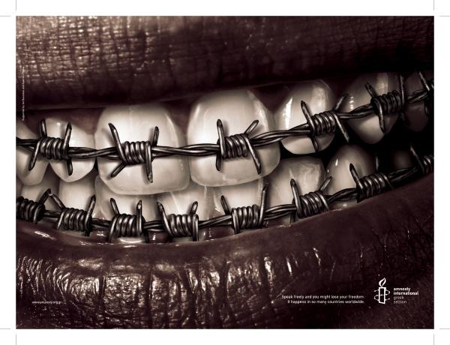
TEXT 3
Speak freely and you might lose your freedom. It happens in so many countries worldwide.

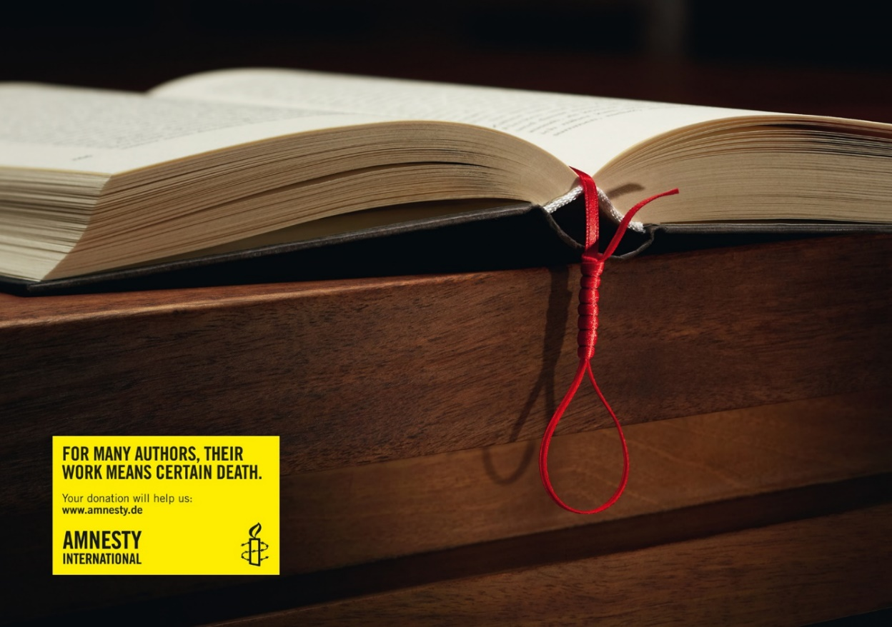
TEXT 4

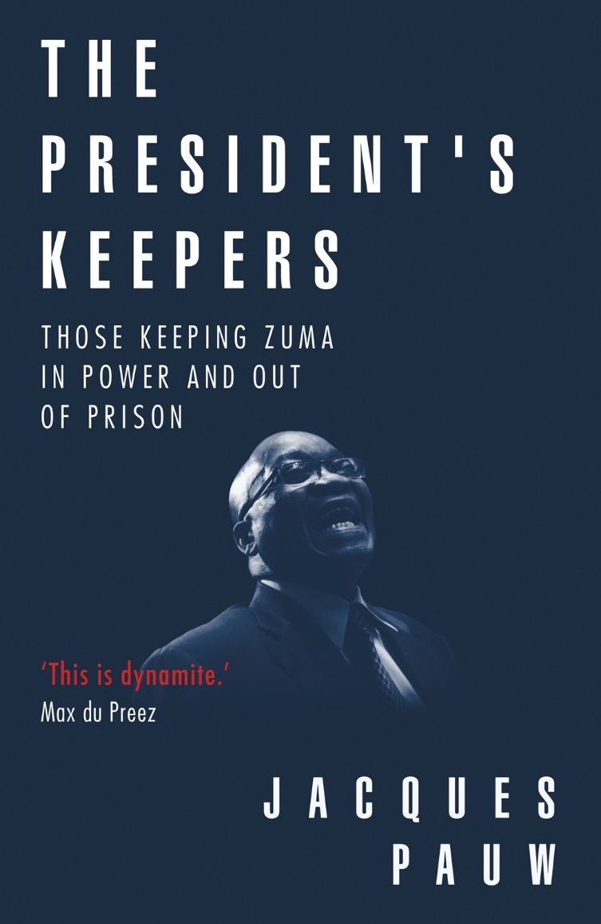
TEXT 5

TEXT 6
Top Kid and Teen Blogs
Tavi Gevinson, Style Rookie
Style rookie? More like seasoned pro. The fashion industry probably weren't prepared for the influence Gevinson, who started her "Style Rookie" lifestyle and inspiration blog at age 11, would eventually have as a tastemaker, fashion rule-breaker, and insightful commenter on trends. She met Vogue editor-in-chief, Anna Wintour, received goodies from top designers, and most recently, worked with magazine maven Jane Pratt on a potential website. We like how it seems as if she never takes herself too seriously and acknowledges the fact that despite her fashion-world cred and over 33,000 Twitter followers, she still has to make it to her English class on time.

Glibly – superficial answer; insincere.
Chides – to express disapproval of specific behaviour; to scold.
Presumption – an idea that is taken to be true on the basis of probability; behaviour perceived to be arrogant and disrespectful.

